Board Meeting
December 11 @ 12:00p.m
7000 Archer Road Justice, IL 60458
Teleconference Line 978-990-5007, Enter access code 718309.
AGENDA

Commission Chairman Mary Jane Mannella called the Meeting of December 11, 2025, to order at

Roll Call

COMMISSIONERS  mary jane mannella  GEORGE PASTORINO  john Zapala | 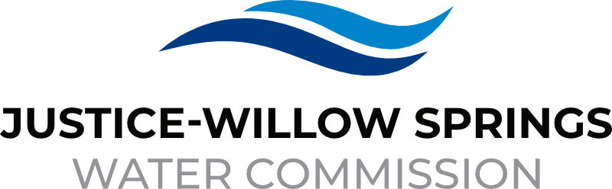 | 7000 sOUTH aRCHER rOAD  jUSTICE, IL 60458-1196  PHONE: 708-458-7010  WWW.JWSWC.ORG
Public Comment

Motion by: ________ to open the floor for public comment.
Second by: _________
Roll Call Vote:

Motion by: _________ to close the floor for public comment.
Second by: __________
Roll Call Vote:

Minutes

Approval of board meeting minutes on October 23, 2025
Motion by:
Second by
Roll Call Vote:

Financial

- Paid Invoices from October 22, 2025 – December 9, 2026 $1,455,760.24
Motion by:
Second by
Roll Call Vote:

- Cash in Banks, All Accounts October and November 2025

- Audit Update

- Discussion and Approval of 2025 General Fund Budget
Motion by:
Second by:
Roll Call Vote:

- Discussion and Approval of 2025 Capital Improvement Budget
Motion by:
Second by:
Roll Call Vote:

- Collections Justice and Willow Springs

Commissioner Report

- Letter from the Village of Willow Springs requesting a registration fee for their annual tree trim.
Donation $100.00
Motion by:
Second by:
Roll Call Vote:

- Letter from the Village of Justice requesting a donation for their Holiday Program/Scholarship Program.
Donation $1500.00
Motion by:
Second by:
Roll Call Vote:

- Approval of regular board meeting dates for 2026
Motion by:
Second by:
Roll Call Vote:

- Approval of Holiday Schedule for 2026
Motion by:
Second by:
Roll Call Vote:

- Christmas bonuses for all employees
Motion by:
Second by:
Roll Call Vote:

Engineer’s Report

- Approval of releasing retainer/final payment to Gerardi Sewer and Company for the 79th Court Project in the amount of $69,986.50.
Motion by:
Second by:
Roll Call Vote:

- Approval of final payment (minus retainer) to Mauro Sewer Construction for East Ravine in the amount of $281,854.63
Motion by:
Second by:
Roll Call Vote:

- Archer Avenue IDOT storm sewer conflict with JWSWC 24" main status update.

- Headquarters Architectural Concept Plan status update.

- Village of Justice 75th Street project status update: Dispute regarding cost assignments for storm sewer replacements

Legal

- Update on Chief Trailer Park

Executive Directors Report

- Liability and health insurance renewal

- Village of Willow Springs Winter Fest

- Village of Justice Winter Wonderland

- Chicago water partner advisory council (CWPAL) – cost of service study

- Meeting with the Village of Bedford Park – CWPAL

- Update on Cook County Project

Operator – Field Report

- Update on Water Main Breaks

- Hodgkins’s emergency inter-connect update

Customer/Community Matters

- Appeal Letter from Dolores Trachitella, 117 Santa Fe requesting a reduction on her water bill.
Reduction Amount:
Motion by:
Second by:
Roll Call Vote:

Personnel

- Acceptance of employees’ FMLA request
Motion by:
Second by:
Roll Call Vote:

Old Business

- Present any Old Business

New Business

- Present / Consider any New Business

Closed Session

A Closed Session, as permitted by 5 ILCS 120/2, will be held to discuss and consider the appointment, compensation, discipline, performance, or dismissal of specific employees of and / or to the Commission.

Motion by: __________ that the Commission suspends the regular meeting and enters a closed session to discuss and consider the appointment, compensation, discipline, performance, or dismissal of specific employees of and / or to the Commission.

Motion by: ___________ that all Correspondence and Documents received by and / or presented to the Commission for this meeting be received, accepted, and filed as noted.
Second by: _________
Roll Call Vote:

Motion by: __________ that the Commission adjourns the Board Meeting of December 11, 2025
Second by: __________
Roll Call Vote:

