Board Meeting
July 18, 2024, at 9:30 a.m.
7000 Archer Road Justice, IL 60458
Teleconference Line 978-990-5007, Enter access code 718309.
MEETING MINUTES

Commission Chairman Mary Jane Mannella called the Meeting of July 18, 2024, to order at 9:36a.m.

Roll Call
Present were the following:
Mary Jane Mannella - Commission Chairman
George Pastorino - Commissioner Treasurer
Colleen Kelly - Commission Executive Director
Mike Cainkar – Attorney
Mary Lancaster – WRDR
Riley Martin – Lauterbach and Amen - auditor
Paul Gal – Water Operator for JWSWC
Tabatha Sutera – Recording Secretary

COMMISSIONERS  mary jane mannella  GEORGE PASTORINO | 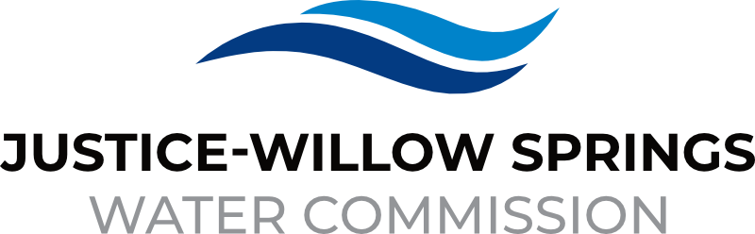 | 7000 sOUTH aRCHER rOAD  jUSTICE, IL 60458-1196  PHONE: 708-458-7010  WWW.JWSWC.ORG
Public Comment

Motion by: Mannella to open the floor for public comment.
Second by: Pastorino
Roll Call Vote: 2/1

Motion by: Mannella to close the floor for public comment.
Second by: Pastorino
Roll Call Vote: 2/1

Minutes

Approval of board meeting minutes on May 2nd, 2024, and June 6th, 2024
Motion by: Mannella
Second by: Pastorino
Roll Call Vote: 2/1

Financial

- Paid Invoices from May 28, 2024 – July 16, 2024 - $1,600,547.51
Motion by: Mannella
Second by: Pastorino
Roll Call Vote: 2/1

- Presentation of 2023 Final Audit.
Presented by: Riley Martin – Audit manager with Lauterbach and Amen
- Statement on audit – general board communication letter
- No difficulties with management
- Annual balance report – financial reports are fair
- Did not identify any issues
- Great year for the Commission
- Operating revenue and expenses
- No issues were found, and the Commission is at a great standing for 2023

- Cash in Banks All Accounts May and June 2024
Up in revenue

- Willow Springs Collections

Commissioner Report

Engineers Report

- Update on 81st Street, awarded to Trine Construction
- $690,228 awarded – this was budgeted by $850,000
- Start date September 8, 2024 – projected completion November 28, 2024
- One of Mackie’s engineers will be on site everyday

- 79th court is coming to final stages – 3rd week of August start date

- Cork Ave/88th Ave weekly meeting – K5 was awarded 8100-Archer Ave – will not be done this year – projected 2025

Legal

Executive Directors Report

- Chief Trailer Park scheduled for 08/09/2024

- Propose budget meeting date
- August 22, 2024 – Budget meeting at 9:30am
- Regular scheduled meeting at 10:30am

- Federal and State Tax update
- Completed and uploaded all information needed.

- Chicago Water Advisory meeting report
- Coalition advisory board
- 38 communities represented there
- Accepted and created by-laws for the council

- Possible upgrade outdated Alarm Fire Security System
- System is outdated
- Upgrade needed, $6000.00 possible cost

Operator – Field Report – Paul Gal
- 9 water main breaks in Justice and 2 in Willow Springs
- CCR was submitted to the EPA
- Lead Copper samples currently in progress

Customer/Community Matters

Personnel

- Discussion and possible approval on annual cost of living increase for employees
Approval on 3% cost of living increase for all employees
Motion by: Mannella
Second by: Pastorino
Roll Call Vote: 2/1

Old Business

- Present any Old Business

New Business

- Present / Consider any New Business

Closed Session

A Closed Session, as permitted by 5 ILCS 120/2, will be held to discuss and consider the appointment, compensation, discipline, performance, or dismissal of specific employees of and / or to the Commission.

Motion by: Mannella that the Commission suspends the regular meeting and enters a closed session to discuss and consider the appointment, compensation, discipline, performance, or dismissal of specific employees of and / or to the Commission.

Motion by: Mannella that all Correspondence and Documents received by and / or presented to the Commission for this meeting be received, accepted, and filed as noted.

Second by: Pastorino
Roll Call Vote: 2/1

Motion by: Pastorino that the Commission adjourns the Board Meeting of July 18, 2024 @ 10:30 am

Second by: Mannella
Roll Call Vote: 2/1

