Board Meeting
November 21, 2024 @ 9:30 am.
7000 Archer Road Justice, IL 60458
Teleconference Line 978-990-5007, Enter access code 718309.
AGENDA

Commission Chairman Mary Jane Mannella called the Meeting of November 21, 2024, to order at

Roll Call

COMMISSIONERS  mary jane mannella  GEORGE PASTORINO | 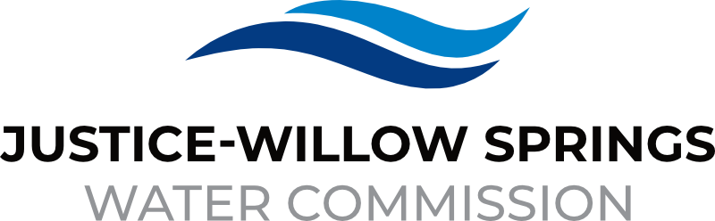 | 7000 sOUTH aRCHER rOAD  jUSTICE, IL 60458-1196  PHONE: 708-458-7010  WWW.JWSWC.ORG
Public Comment

Motion by: _________ to open the floor for public comment.
Second by: _________
Roll Call Vote:

Motion by: _________ to close the floor for public comment.
Second by: __________
Roll Call Vote:

Minutes

Approval of board meeting minutes on October 25, 2024
Motion by:
Second by
Roll Call Vote:

Approval of Budget meeting on August 22, 2024
Motion by:
Second by
Roll Call Vote:

Financial

- Paid Invoices from October 22,2024-
Motion by:
Second by
Roll Call Vote:

- Budget Report

- Cash in Banks, All Accounts October 2024

- Willow Springs, Justice and Commercial Collections

Commissioner Report

- Letter from the Village of Willow Springs requesting a registration fee for their annual trim tree that will benefit Willow Springs Parks and Recreation Commission
Donation Amount: $100.00
Motion by:
Second by:
Roll Call Vote:

Engineer’s Report

- Discussion and Approval of invoice in the amount of $27,609.53 submitted by Mackie on behalf of Unique Plumbing for the Charleton Project extension
Motion by:
Second by:
Roll Call Vote:

- Discussion and Approval on first pay-out to Gerardi Sewer & Water company for the 79th Court project in the among of $1,311,056.10
Motion by:
Second by:
Roll Call Vote:

- Project Updates
  - 2025 Project East Ravine
  - 79th Court
  - 79th Street
  - 81st Street
  - Meeting with Village of Justice
  - LMO-2 water loss report update

Legal
- Discussion and approval of Quality Alarm, burglar and fire alarm lease system installation and service agreement for main building, float house and high tank
Motion by:
Second by
Roll Call Vote:

- Approval of Intergovernmental agreement 2024-16 between the Justice-Willow Springs Water Commission and the Village of Justice for sanitary sewer improvements as part of the Justice 79th Court watermain replacement project
Motion by:
Second by
Roll Call Vote:

Executive Directors Report

- St. Laurence career day participation

- Update on Chief Trailer Park

- Iso rating – Roberts Park Fire Department improvement

- Update: 88th Ave and Archer construction

- Attendance of Chicago’s Annual Strategic Partner Tabletop exercise on September 16,2024.

- Attendance of City of Chicago advisory council meeting on September 10, 2024

- Update on Hydrant flow testing/maintenance program.

Operator – Field Report

- Willow Springs meter pit
- Construction

Customer/Community Matters

- Appeal Letter from Jakob Pallisard, 106 North Pearl requesting a reduction on his water bill.
Reduction Amount:
Motion by:
Second by:
Roll Call Vote:

- Update on 8515 – decision in August meeting was to table to request until he could fill out the paperwork properly. I called and spoke with him on 08/27/2024, he advised he would fill out the paperwork, we have not received anything regarding the water leak since.

- Appeal Letter from Joan Schrock, 7120 South 86th Avenue requesting a reduction on her water bill.
Reduction Amount:
Motion by:
Second by:
Roll Call Vote:

- Appeal Letter from Robert Coronado, 8404 South 79th Ave requesting a reduction on his water bill.
Reduction Amount:
Motion by:
Second by:
Roll Call Vote:

Personnel

Old Business

- Present any Old Business

New Business

- Present / Consider any New Business

Closed Session

A Closed Session, as permitted by 5 ILCS 120/2, will be held to discuss and consider the appointment, compensation, discipline, performance, or dismissal of specific employees of and / or to the Commission.

Motion by: __________ that the Commission suspends the regular meeting and enters a closed session to discuss and consider the appointment, compensation, discipline, performance, or dismissal of specific employees of and / or to the Commission.

Motion by: __________ that all Correspondence and Documents received by and / or presented to the Commission for this meeting be received, accepted, and filed as noted.

Second by: _________
Roll Call Vote:

Motion by: __________ that the Commission adjourns the Board Meeting of October 24,2024

Second by: __________
Roll Call Vote:

