Board Meeting
May 12, 2025 @ 9:30am.
7000 Archer Road Justice, IL 60458
Teleconference Line 978-990-5007, Enter access code 718309.
AGENDA

Commission Chairman Mary Jane Mannella called the Meeting of May 12, 2025, to order at

Roll Call

COMMISSIONERS  mary jane mannella  GEORGE PASTORINO | 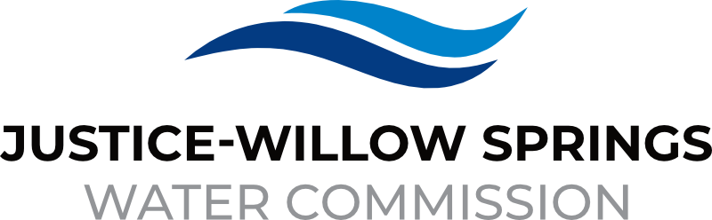 | 7000 sOUTH aRCHER rOAD  jUSTICE, IL 60458-1196  PHONE: 708-458-7010  WWW.JWSWC.ORG
Public Comment

Motion by: ________ to open the floor for public comment.
Second by: _________
Roll Call Vote:

Motion by: _________ to close the floor for public comment.
Second by: __________
Roll Call Vote:

Minutes

Approval of board meeting minutes on March 27, 2025
Motion by:
Second by
Roll Call Vote:

Financial

- Paid Invoices from April 22, 2025- May 9, 2025 - $153,065.14
Motion by:
Second by
Roll Call Vote:

- Cash in Banks, All Accounts April 2025

Commissioner Report

- Letter from the Village of Willow Springs requesting a donation for the Windy City Blues Fest and the Annual Benefit Car show that will take place July 24, 2024 – July 27, 2025
Donation Amount: $
Motion by:
Second by:
Roll Call Vote:

- Letter from the Village of Justice noting the cancellation of their annual car show for 2025.
2026 Car show will be held on Friday August 28, 2026.

- Letter from Willow Springs Lions Club requesting a donation
Donation Amount: $
Motion by:
Second by:
Roll Call Vote:

Engineer’s Report

- Review and award contract to a low qualified bidder for the East Ravine Project
Motion by:
Second by:
Roll Call Vote:

- Discussion and possible motion on draft development agreement between JWSWC and QuikTrip
Motion by:
Second by:
Roll Call Vote:

- Discussion and possible motion on East Ravine easement agreement and terms
Motion by:
Second by:
Roll Call Vote:

Legal

Executive Directors Report

- Discussion and possible approval to waive the connection fee for Village of Willow Beatification Garden
Motion by:
Second by:
Roll Call Vote:

- Discussion of revision to ordinance 2005-04, The procedure for shutting off a water service by the Commission for the user’s failure to pay a delinquent water bill and procedures for notice to the user and user’s request for a hearing before the Commission

Operator – Field Report

- Update on Rosary Hill Meter replacement

- Update on Willow Springs meter pit

- Update Cook County Cork Project

Customer/Community Matters

- Appeal Letter from Benjamin Vohn, 509 South Nolton requesting a reduction on his water bill.
Reduction Amount:
Motion by:
Second by:
Roll Call Vote:

Personnel

Old Business

- Present any Old Business

New Business

- Present / Consider any New Business

Closed Session

A Closed Session, as permitted by 5 ILCS 120/2, will be held to discuss and consider the appointment, compensation, discipline, performance, or dismissal of specific employees of and / or to the Commission.

Motion by: __________ that the Commission suspends the regular meeting and enters a closed session to discuss and consider the appointment, compensation, discipline, performance, or dismissal of specific employees of and / or to the Commission.

Motion by: ___________ that all Correspondence and Documents received by and / or presented to the Commission for this meeting be received, accepted, and filed as noted.

Second by: _________
Roll Call Vote:

Motion by: __________ that the Commission adjourns the Board Meeting of May 12, 2025

Second by: __________
Roll Call Vote:

