Board Meeting
March 27, 2025 @ 9:30am.
7000 Archer Road Justice, IL 60458
Teleconference Line 978-990-5007, Enter access code 718309.
AGENDA

Commission Chairman Mary Jane Mannella called the Meeting of March 27, 2025, to order at

Roll Call

COMMISSIONERS  mary jane mannella  GEORGE PASTORINO | 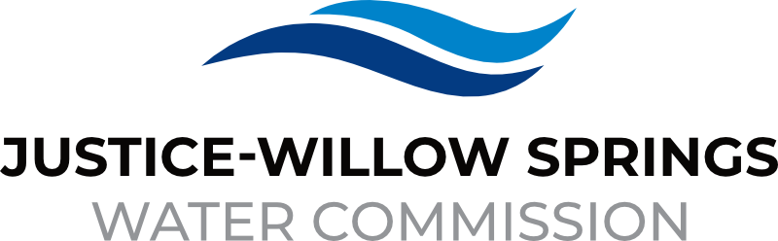 | 7000 sOUTH aRCHER rOAD  jUSTICE, IL 60458-1196  PHONE: 708-458-7010  WWW.JWSWC.ORG
Public Comment

Motion by: ________ to open the floor for public comment.
Second by: _________
Roll Call Vote:

Motion by: _________ to close the floor for public comment.
Second by: __________
Roll Call Vote:

Minutes

Approval of board meeting minutes on January 23, 2025
Motion by:
Second by
Roll Call Vote:

Financial

- Paid Invoices from January 20, 2025- March 24, 2025 - $1,130,097.60
Motion by:
Second by
Roll Call Vote:

- Cash in Banks, All Accounts January and February 2025

- 5/3 security investment schedule

- Two CODs matured on 02/28/2025, both CD’s are a 12 month term and the rate is 3.93%

- Willow Springs Collections

Commissioner Report

- Letter from The Justice Fraternal Police requesting a donation for their 2025 fundraiser.
Donation Amount:
Motion by:
Second by:
Roll Call Vote:

- Approval for 2025 SSWWA Golf outing, sponsorship
Donation Amount:
Motion by:
Second by:
Roll Call Vote:

Engineer’s Report

- LMO-2 update, down 9% loss vs 14% in 2023.

- Discussion on Sterling Estates request for water storage agreement

- Discussion of Unique Plumbing payment request for Charleton Ave

- Update on East Ravine

- Final Payout to Gerardi for the 79th Street Water Main Replacement in the amount of $72,990.31.
Motion by:
Second by:
Roll Call Vote:

Legal

Executive Directors Report

- Update on rate change for IMRF

- Update on Chief Trailer Park

- Discussion and possible approval on repair and replacement of VFD pump control in upper pumping station.
Motion by:
Second by:
Roll Call Vote:

- Update on computer upgrade

- CWPAC Executive Committee

- Discussion on Cook County Leak Repair Program.

- Update on Audit

Operator – Field Report

- Burr Ridge interconnect

- Oaks of Willow Hill structure fire

Customer/Community Matters

- Appeal Letter from Sharon Park and Richard Gaona, 8145 South 83rd Avenue requesting a reduction on their water bill.
Reduction Amount:
Motion by:
Second by:
Roll Call Vote:

- Appeal Letter from Henry Ventimiglia, 7932 South 86th Court requesting a reduction on her water bill.
Reduction Amount:
Motion by:
Second by:
Roll Call Vote:

Personnel

- Discussion and possible approval of fulfilling vacant position
Motion by:
Second by:
Roll Call Vote:

Old Business

- Present any Old Business

New Business

- Present / Consider any New Business

Closed Session

A Closed Session, as permitted by 5 ILCS 120/2, will be held to discuss and consider the appointment, compensation, discipline, performance, or dismissal of specific employees of and / or to the Commission.

Motion by: __________ that the Commission suspends the regular meeting and enters a closed session to discuss and consider the appointment, compensation, discipline, performance, or dismissal of specific employees of and / or to the Commission.

Motion by: ___________ that all Correspondence and Documents received by and / or presented to the Commission for this meeting be received, accepted, and filed as noted.

Second by: _________
Roll Call Vote:

Motion by: __________ that the Commission adjourns the Board Meeting of March 24, 2025

Second by: __________
Roll Call Vote:

