Board Meeting
June 6, 2024.
7000 Archer Road Justice, IL 60458
Teleconference Line 978-990-5007, Enter access code 718309.
AGENDA

Commission Chairman Mary Jane Mannella called the Meeting of June 6, 2024, to order at

Roll Call

COMMISSIONERS  mary jane mannella  GEORGE PASTORINO | 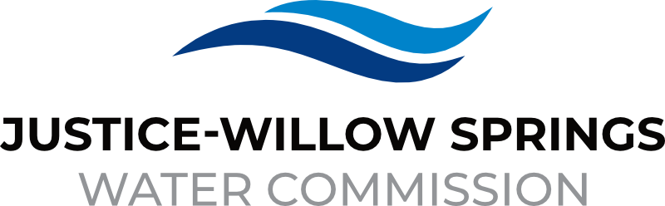 | 7000 sOUTH aRCHER rOAD  jUSTICE, IL 60458-1196  PHONE: 708-458-7010  WWW.JWSWC.ORG
Public Comment

Motion by: _________ to open the floor for public comment.
Second by: _________
Roll Call Vote:

Motion by: _________ to close the floor for public comment.
Second by: __________
Roll Call Vote:

Minutes

Approval of board meeting minutes on May 2, 2024
Motion by:
Second by
Roll Call Vote:

Financial

- Paid Invoices from April 30, 2024, to May 28, 2024 - $263,752.94
Motion by:
Second by
Roll Call Vote:

- Cash in Banks All Accounts April 2024

- Justice and Commercial Collections

Commissioner Report

- Letter from the Village of Willow Springs requesting a donation for the Windy City Blues Fest that will take place on July 24, 2024.
Donation Amount:
Motion by:
Second by:
Roll Call Vote:

- Letter from the Justice Chamber of Commerce requesting a donation for the annual Rib Fest that took place on May 18, 2024
Donation Amount:
Motion by:
Second by:
Roll Call Vote:

- Letter from the Village of Justice requesting a donation for their 27th annual car show that will take place August 23, 2024
Donation Amount:
Motion by:
Second by:
Roll Call Vote:

- Letter from the Village of Willow requesting a donation for the annual Willow Fest that will take place August 11, 2024.
Donation Amount:
Motion by:
Second by:
Roll Call Vote:

Engineers Report

- Discuss the IEPA Water Audit Submittal.

- Approval of 79th Court bid and contract award recommendation letter from Mackie Consultants
Motion by:
Second by
Roll Call Vote:

- 79th Street Hotel Update: Engineer’s estimate of cost to construct the developer’s portion and recover same via recapture agreement. Full plans have been permitted, subject to contractor bond submittal to IDOT.

- Cook County 79th Street and Archer Avenue construction implications update.

- Approval on Water Appeal Letter
Motion by:
Second by:
Roll Call Vote:

Legal

Executive Directors Report

- Motion to accept MWRD Easement agreement
Motion by:
Second by:
Roll Call Vote:

- Update on the Lyons Township summer intern placements

- Discussion on Maren Ronan State Grant Award in the amount of $75,000

Operator – Field Report

Customer/Community Matters

- Letter from Diane Michelini, 8415 Provence requesting a reduction on her water bill.
Reduction Amount:
Motion by:
Second by:
Roll Call Vote:

Personnel

Old Business

- Present any Old Business

New Business

- Present / Consider any New Business

Closed Session

A Closed Session, as permitted by 5 ILCS 120/2, will be held to discuss and consider the appointment, compensation, discipline, performance, or dismissal of specific employees of and / or to the Commission.

Motion by: __________ that the Commission suspends the regular meeting and enters a closed session to discuss and consider the appointment, compensation, discipline, performance, or dismissal of specific employees of and / or to the Commission.

Motion by: __________ that all Correspondence and Documents received by and / or presented to the Commission for this meeting be received, accepted, and filed as noted.

Second by: _________
Roll Call Vote:

Motion by: __________ that the Commission adjourns the Board Meeting of June 6, 2024

Second by: __________
Roll Call Vote:

