Board Meeting
August 22, 2024 @ 10:30 am.
7000 Archer Road Justice, IL 60458
Teleconference Line 978-990-5007, Enter access code 718309.
AGENDA

Commission Chairman Mary Jane Mannella called the Meeting of August 22,2024, to order at

Roll Call

COMMISSIONERS  mary jane mannella  GEORGE PASTORINO | 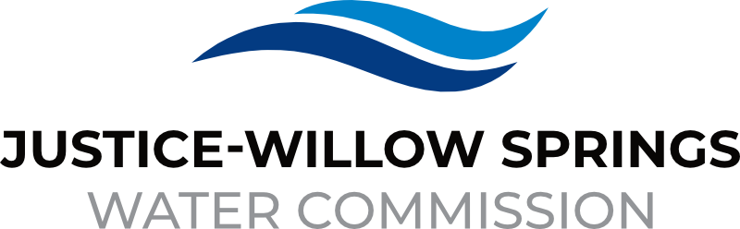 | 7000 sOUTH aRCHER rOAD  jUSTICE, IL 60458-1196  PHONE: 708-458-7010  WWW.JWSWC.ORG
Public Comment

Motion by: _________ to open the floor for public comment.
Second by: _________
Roll Call Vote:

Motion by: _________ to close the floor for public comment.
Second by: __________
Roll Call Vote:

Minutes

Approval of board meeting minutes on July 19, 2024
Motion by:
Second by
Roll Call Vote:

Financial

- Paid Invoices from July 19, 2024 - August 20, 2024 - $ 608,732.31
Motion by:
Second by
Roll Call Vote:

- Cash in Banks All Accounts July 2024

- Willow Springs and Commercial Collections

Commissioner Report

- Approval of Audit prepared by Lauterbach & Amen for fiscal year 2023.
Motion by:
Second by
Roll Call Vote:

- Letter from the Argo-Summit, Bridgeview and Justice Lions club requesting a donation for their 3rd annual Oktoberfest that will take place on September 14, 2024.
Donation Amount:
Motion by:
Second by:
Roll Call Vote:

Engineers Report

- Discussion and possible of approval of current projects

Legal

- Approval of Intergovernmental agreement between the Justice-Willow Springs Water Commission and the Village of Justice for watermain improvements as part of the Justice 81st Street improvement project
Motion by:
Second by:
Roll Call Vote:

- Discussion and possible approval of contract presented between Valdes Engineering Company and Justice Willow Springs Water Commission for engineering permit review services.
Motion by:
Second by:
Roll Call Vote:

- Discussion and possible action for a letter set by Lambert Worldwide regarding courtesy request of Simarjit Bhalla.
Motion by:
Second by:
Roll Call Vote:

Executive Directors Report

- Discussion and Approval of invoice submitted by the Village of Justice for payment of 81st watermain improvement per the IGA in the amount of $517,671.00
Motion by:
Second by:
Roll Call Vote:

- Discussion and possible approval to change monthly utility vendors method of payment due to the fees we accrue with paying the bills monthly
Motion by:
Second by
Roll Call Vote:

- Update on Willow Fest and Justice Car Show

- Discussion and approval for seasonal employees’ employment and compensation as needed
Motion by:
Second by
Roll Call Vote:

- Update on Chief Trailer Park

- Discussion regarding drone GIS project by 9 Line Aerial Media, LLC

Operator – Field Report

Customer/Community Matters

- Appeal Letter from Aicha Lamkadmi, 8651 West 71st Street requesting a reduction on his water bill.
Reduction Amount:
Motion by:
Second by:
Roll Call Vote:

- Appeal Letter from Samantha Dobson, 7735 Cronin requesting a reduction on her water bill.
Reduction Amount:
Motion by:
Second by:
Roll Call Vote:

- Appeal Letter from Ayham Alagha, 7651 Parkview requesting a reduction on his water bill.
Reduction Amount:
Motion by:
Second by:
Roll Call Vote:

- Appeal Letter from Fakhry Nakira, owner of JJ Fish, 8515 88th Ave is requesting a reduction on his water bill.
Reduction Amount:
Motion by:
Second by:
Roll Call Vote:

Personnel

Old Business

- Present any Old Business

New Business

- Present / Consider any New Business

Closed Session

A Closed Session, as permitted by 5 ILCS 120/2, will be held to discuss and consider the appointment, compensation, discipline, performance, or dismissal of specific employees of and / or to the Commission.

Motion by: __________ that the Commission suspends the regular meeting and enters a closed session to discuss and consider the appointment, compensation, discipline, performance, or dismissal of specific employees of and / or to the Commission.

Motion by: __________ that all Correspondence and Documents received by and / or presented to the Commission for this meeting be received, accepted, and filed as noted.

Second by: _________
Roll Call Vote:

Motion by: __________ that the Commission adjourns the Board Meeting of August 22, 2024.

Second by: __________
Roll Call Vote:

