Board Meeting
April 4, 2024 at 9:30 a.m.
7000 Archer Road Justice, IL 60458
Teleconference Line 978-990-5007, Enter access code 718309.
AGENDA

Commission Chairman Mary Jane Mannella called the Meeting of April 4,2024, to order at

Roll Call

COMMISSIONERS  mary jane mannella  GEORGE PASTORINO  mike porfirio | 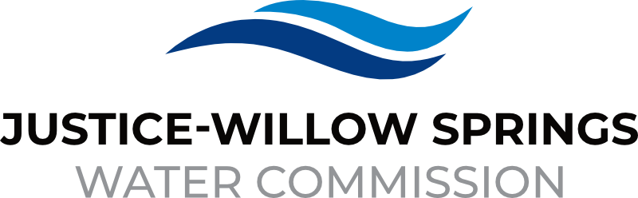 | 7000 sOUTH aRCHER rOAD  jUSTICE, IL 60458-1196  PHONE: 708-458-7010  WWW.JWSWC.ORG
Public Comment

Motion by: _________ to open the floor for public comment.
Second by: _________
Roll Call Vote:

Motion by: _________ to close the floor for public comment.
Second by: __________
Roll Call Vote:

Minutes

Approval of board meeting minutes and Budget meeting minutes on February 22 ,2024
Motion by:
Second by
Roll Call Vote:

Approval of board meeting minutes for postponing the March 28, 2024, meeting.
Motion by:
Second by
Roll Call Vote:

Financial

- Paid Invoices from February 20, 2024 – March 25,2024 - $803,341.41
Motion by:
Second by
Roll Call Vote:

- Cash in Banks All Accounts February 2024

- Justice Collections

Commissioner Report

Engineers Report

- Update on all unopened projects.

Legal

- Discussion and possible approval on 8721 Industrial Drive.
Motion by:
Second by
Roll Call Vote:

- Approval of Intergovernmental agreement between the Illinois State Toll Highway Authority and the Justice-Willow Springs Water Commission to improve certain portions of the Tri-State Tollway mainline between 95th Street and Balmoral Avenue
Motion by:
Second by
Roll Call Vote:

Executive Directors Report

- Notice of Chicago Rate Increase

- Notice to City of Hickory Hills rate increase.

- Discussion and possible approval on changing the provider for life and disability policy, $158.76 difference.
Motion by:
Second by
Roll Call Vote:

- Postpone budget approval meeting until April.

Customer/Community Matters

- Letter from Nancy Franke, 110 Fairway Drive requesting a reduction on her water bill.
Reduction Amount:
Motion by:
Second by:
Roll Call Vote:

- Letter from Bozena Adamska, 7160 Cork requesting a reduction on his water bill.
Reduction Amount:
Motion by:
Second by:
Roll Call Vote:

- Letter from Ted Kapecki, 7541 Oak Grove Avenue requesting a reduction on his water bill.
Reduction Amount:
Motion by:
Second by:
Roll Call Vote:

- Letter from A.L. Haines, 7657 Creekside requesting a reduction on her water bill.
Reduction Amount:
Motion by:
Second by:
Roll Call Vote:

- Letter from Willan Scott, 7965 Bielby Lane, requesting a reduction on his water bill.
Reduction Amount:
Motion by:
Second by:
Roll Call Vote:

- Letter from Zuzana Gabrisak, 8525 Candlelight Drive West, requesting a reduction on her water bill.
Reduction Amount:
Motion by:
Second by:
Roll Call Vote:

- Letter from Andrzej Makuch, 7515 Banks, requesting a reduction on his water bill.
Reduction Amount:
Motion by:
Second by:
Roll Call Vote:

Personnel

Old Business

- Present any Old Business

New Business

- Present / Consider any New Business

Closed Session

A Closed Session, as permitted by 5 ILCS 120/2, will be held to discuss and consider the appointment, compensation, discipline, performance, or dismissal of specific employees of and / or to the Commission.

Motion by: __________ that the Commission suspends the regular meeting and enters a closed session to discuss and consider the appointment, compensation, discipline, performance, or dismissal of specific employees of and / or to the Commission.

Motion by: __________ that all Correspondence and Documents received by and / or presented to the Commission for this meeting be received, accepted, and filed as noted.

Second by: _________
Roll Call Vote:

Motion by: __________ that the Commission adjourns the Board Meeting of April 4, 2024

Second by: __________
Roll Call Vote:

