Board Meeting
April 24, 2025 @ 9:30am.
7000 Archer Road Justice, IL 60458
Teleconference Line 978-990-5007, Enter access code 718309.
AGENDA

Commission Chairman Mary Jane Mannella called the Meeting of April 24, 2025, to order at

Roll Call

COMMISSIONERS  mary jane mannella  GEORGE PASTORINO | 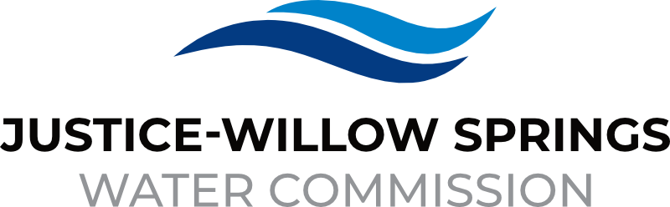 | 7000 sOUTH aRCHER rOAD  jUSTICE, IL 60458-1196  PHONE: 708-458-7010  WWW.JWSWC.ORG
Public Comment

Motion by: ________ to open the floor for public comment.
Second by: _________
Roll Call Vote:

Motion by: _________ to close the floor for public comment.
Second by: __________
Roll Call Vote:

Minutes

Approval of board meeting minutes on March 27, 2025
Motion by:
Second by
Roll Call Vote:

Financial

- Paid Invoices from March 24, 2025- April 21, 2025 - $710,135.86
Motion by:
Second by
Roll Call Vote:

- Cash in Banks, All Accounts March 2025

- Renewal of CD from Republic Bank, renewed at 3.80% for 12 months.

- Capital Improvement Project Budget discussion

- Willow Springs Collections

Commissioner Report

Engineer’s Report

- Final Payment on the Intergovernmental agreement between the Village of Justice and JWSWC for the Marion Drive Project in the amount of $87,004.13
Motion by:
Second by
Roll Call Vote:

- Approval of final payment on Charleton Project.
Motion by:
Second by
Roll Call Vote:

- Update on East Ravine bidding schedule, Easements are still in process, all permits are in hand
Motion by:
Second by
Roll Call Vote:

- Discussion and possible approval on 79th Street 20” loop link at QuikTrip.
Motion by:
Second by
Roll Call Vote:

- IDNR still has not provided LMO-2 reporting forms for 2024. We are done with the math, and results were compliant but can’t submit until they provide the updated forms.

- Discussion and approval on partial release retainer for Geradi Sewer and Water Company for 79th Court Water Main
Motion by:
Second by
Roll Call Vote:

Legal

- Notification was sent to the Village of Hickory Hills on rate increase effective June 1, 2025, regarding City of Chicago annual rate increase.

- Approval of Intergovernmental agreement between the Lyons Township and Justice-Willow Springs Water Commission for the Summer Employment Work Program.
Motion by:
Second by
Roll Call Vote:

Executive Directors Report

- Notification was sent to Sterling Estates regarding water storage agreement request

- Discussion of rate change for JWSWC due to Chicago annual rate increase per ordinance on June 1, 2025

- Discussion and approval to authorize Valdes Engineering to release bid for HVAC project.
Motion by:
Second by
Roll Call Vote:

- Discussions and possible approval of the change order for the HVAC project from Valdes Engineering in the amount of $5,600
Motion by:
Second by
Roll Call Vote:

- Discussion of Cook County Tap leak assistance program.

Operator – Field Report

- Willow Springs meter pit project

- Discussion and possible approval of Lower-Level Pump Station Rehabilitation Project and cost estimate
Motion by:
Second by
Roll Call Vote:

- Update of main pump station pump drive replacement.

- Update of Cook Country Cork/Archer Avenue project.

- Discussion and approval pending attorney review of SCADA/Pump Control program in the amount of $19,656.00
Motion by:
Second by
Roll Call Vote:

- Update on Canal Repair Burr Ridge invoice

Customer/Community Matters

- Discussion and approval of tampering fee for 8005 Fawn Trail
Tampering Fee:
Motion by:
Second by:
Roll Call Vote

- Appeal Letter from Sophia Magiera,7358 Cork Avenue requesting a reduction on her water bill.
Reduction Amount:
Motion by:
Second by:
Roll Call Vote:

- Appeal Letter from Jeffrey Allen, 7158 Blackstone requesting a reduction on his water bill.
Reduction Amount:
Motion by:
Second by:
Roll Call Vote:

- Appeal Letter from Greg Koenig, 8033 South 86th Ave requesting a reduction on his water bill.
Reduction Amount:
Motion by:
Second by:
Roll Call Vote:

- Discussion of Cintas, 8201 Cork Ave Justice regarding account billing and usage.

Personnel

- Discussion and approval on cost of living raises for all employees.
Motion by:
Second by:
Roll Call Vote

Old Business

- Present any Old Business

New Business

- New requirements from the EPA, Lead Service Line inventory and the most recent Lead and Copper results in addition to our Water Quality. All are required to be posted online for our consumer to access at their leisure
- New Website is currently in the works, working with Renee and a new website developer.

Closed Session

A Closed Session, as permitted by 5 ILCS 120/2, will be held to discuss and consider the appointment, compensation, discipline, performance, or dismissal of specific employees of and / or to the Commission.

Motion by: __________ that the Commission suspends the regular meeting and enters a closed session to discuss and consider the appointment, compensation, discipline, performance, or dismissal of specific employees of and / or to the Commission.

Motion by: ___________ that all Correspondence and Documents received by and / or presented to the Commission for this meeting be received, accepted, and filed as noted.

Second by: _________
Roll Call Vote:

Motion by: __________ that the Commission adjourns the Board Meeting of April 24, 2025

Second by: __________
Roll Call Vote:

